이승수’s lab5

Lab1)Caesar’s encryption

#include <stdio.h>

#include <stdlib.h>

void main()

{

char temp, tmp[15];

int num, i;

FILE \*infile, \*outfile,\*inF,\*outF;

infile = fopen("original.txt", "r");

printf("add num:");

scanf("%d", &num);

outfile = fopen("cypher.txt", "w");

while (!feof(infile))

{

fscanf(infile, "%c", &temp);//

//if (temp != ' ')

temp += num;

//else

;

fprintf(outfile, "%c", temp);

}

fclose(infile);

fclose(outfile);

inF = fopen("cypher.txt","r");

outF = fopen("decrypted.txt","w");

while (!feof(infile))

{

fscanf(infile, "%s", tmp);

i = 0;

while (tmp[i] != '\0')

{

tmp[i] -= num;

i++;

}

fprintf(outF, "%s", tmp);

}

//outfile = fopen("decrypted.txt", "w");

fclose(outF);

fclose(inF);

}

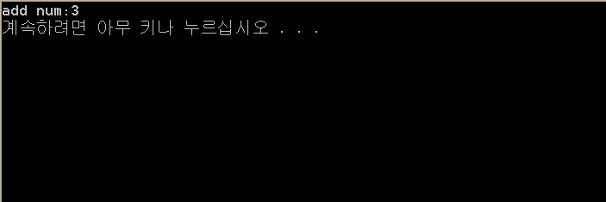

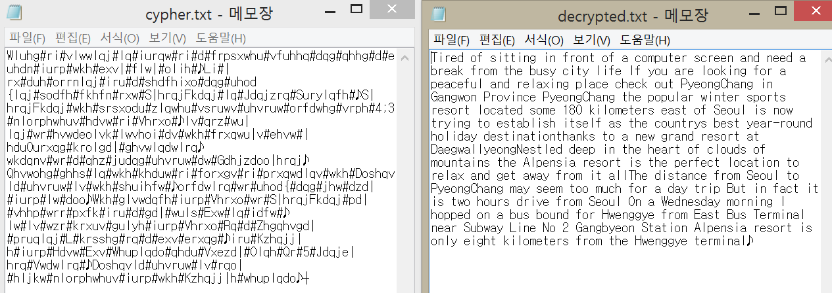

Lab3)

#include <stdio.h>

#include <stdlib.h>

struct info

{

char name[10];

int age;

char hobby[10];

} person[20];//메인에서 선언해주고로도 해보기

void main()

{

FILE \*infile, \*outfile;

int i,j,age;

char space,name[10], hobby[10];

infile = fopen("personal.txt","r");

for (i = 0; i < 20; i++)

{

fscanf(infile, "%s %d %s", person[i].name, &person[i].age, person[i].hobby);

printf("%s %d %s\n", person[i].name, person[i].age, person[i].hobby);

}

fclose(infile);

printf("-------------------------");

struct info temp;

for (i = 0; i < 19;i++)

{

for (j = 0; j < 19-i; j++)

{

if (strcmp(person[j].hobby, person[j + 1].hobby) > 0)

{

temp = person[j];

person[j] = person[j + 1];

person[j + 1] = temp;

}

}

}

outfile = fopen("hobby.txt","w");

for (i = 0; i < 20; i++)

{

fprintf(outfile, "%s %d %s\n", person[i].name, person[i].age, person[i].hobby);

}

fclose(outfile);//hobbycmp end

for (i = 19; i>0; i--)

{

for (j = 0; j < i; j++)

{

if (person[j].age > person[j+1].age)

{

temp = person[j];

person[j] = person[j + 1];

person[j + 1] = temp;

}

}

}

outfile = fopen("age.txt", "w");

for (i = 0; i < 20; i++)

{

fprintf(outfile, "%s %d %s\n", person[i].name, person[i].age, person[i].hobby);

}

fclose(outfile);//agecmp end

}

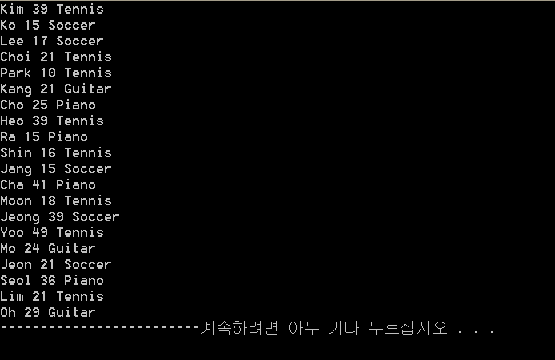

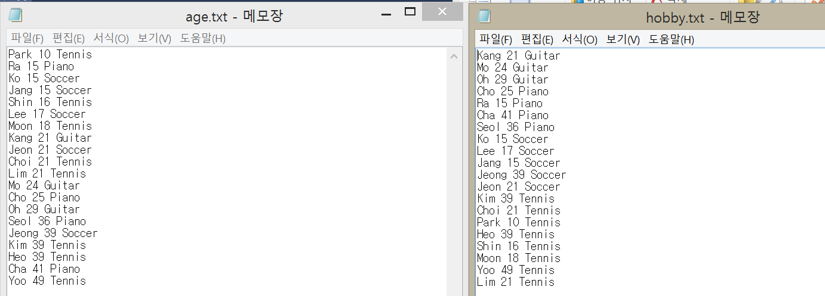

Lab4)

#include <stdio.h>

#include <stdlib.h>

struct info

{

char region[15];

int age;

char cand[15];

} people[2000];

void main()

{

FILE \*infile, \*outfile;

char re[15], cand[15];

float Was=0, Ros=0, Lin=0;

int i=0,age;

float percent,num=0;

infile = fopen("vote.txt","r");

while (fscanf(infile, "%s %d %s", people[i].region, &people[i].age, people[i].cand) != EOF)

{

i++;

}

fclose(infile);

for (i = 0; i < 2000;i++)

{

switch (people[i].cand[0])

{

case 'R':

Ros++;

break;

case 'W':

Was++;

break;

case 'L':

Lin++;

break;

}

num++;

}//count

printf("VOTEDALL\nRoosvelt:%f%% Washingon:%f%% Lincoln:%f%%", 100 \* (Ros / num), 100 \* (Ros / num), 100 \* (Ros / num));

Ros = 0, Was = 0, Lin = 0;

num = 0;

for (i = 0; i < 2000; i+=3)

{

switch (people[i].cand[0])

{

case 'R':

Ros++;

break;

case 'W':

Was++;

break;

case 'L':

Lin++;

break;

}

num++;

}//countby3

printf("\nVOTEDBy3lines\nRoosvelt:%f%% Washingon:%f%% Lincoln:%f%%", 100 \* (Ros / num), 100 \* (Ros / num), 100 \* (Ros / num));

Ros = 0, Was = 0, Lin = 0;

num = 0;

for (i = 0; i < 2000; i += 10)

{

switch (people[i].cand[0])

{

case 'R':

Ros++;

break;

case 'W':

Was++;

break;

case 'L':

Lin++;

break;

}

num++;

}//countby3

printf("\nVOTEDBy10lines\nRoosvelt:%f%% Washingon:%f%% Lincoln:%f%%", 100 \* (Ros / num), 100 \* (Ros / num), 100 \* (Ros / num));

}

